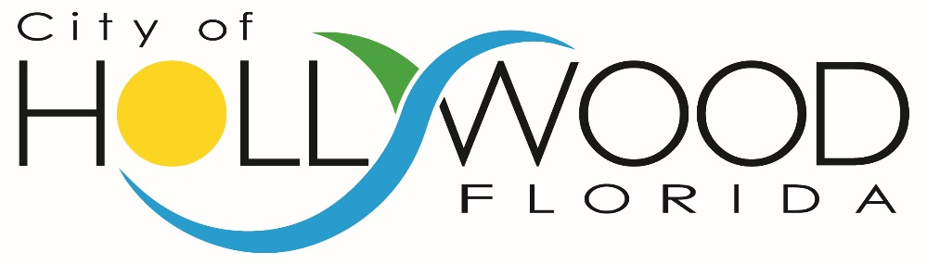
invites your interest in the
position of

DIRECTOR OF FINANCIAL SERVICES

THE COMMUNITY

Rich in history and poised for the future, the City of Hollywood is located within minutes of the second busiest cruise port in the world and adjacent to Fort Lauderdale Hollywood International Airport. It is strategically located between Fort Lauderdale and Miami insuring convenience and access while offering a corporate and residential lifestyle all its own. The City is home to approximately 145,000 residents and has a total area of 31 square miles and is the twelfth largest city in Florida.

Joseph W. Young founded the city in 1925. Young had a vision of having lakes, golf courses, a luxury beach hotel, country clubs, and a main street, Hollywood Boulevard; Hollywood is a planned city. On Hollywood Boulevard is the Mediterranean-style Joseph Young Mansion, built around 1921, making it one of the oldest houses in Hollywood.
Hollywood is filled with about 60 parks, seven golf courses, and sandy beaches that run for more than five miles. The famous Hollywood Beach is known for its great broadwalk that extends about 2.5 miles along the Atlantic Ocean. Parking is available on side streets or in parking garages, and public trolleys run through the day. Countless restaurants and hotels line the broadwalk along with a theatre, children's playground, and many other attractions including bicycle rental shops, ice cream parlors, souvenir shops, and a farmer's market. Many of the restaurants offer outdoor seating for patrons to enjoy the seabreeze and scenery. The broadwalk is vibrant and lively and is a scenic place for walking and jogging; there are also bike lanes for bicyclists and rollerblades. In the evenings, many restaurants and the bandshell off of Johnson Street showcase musicians and spontaneous dancing may occur on the broadwalk.
Young Circle is another exciting area surrounded by dozens of shops, restaurants, and bars. A Food Truck Takeover occurs every Monday, during which dozens of local food trucks park and create an ever-changing opportunity for hungry masses to experience a variety of cuisines; one can expect to see Cuban, Venezuelan, Mediterranean, Mexican, Jamaican, and/or Peruvian foods in addition to barbecue, burgers, gourmet grilled cheese, and dessert trucks.
Hollywood is made up of 32 public and charter schools with 13 private schools. The public schools are operated by the Broward County Public Schools.

Learn more about the City of Hollywood by visiting:

www.hollywoodfl.org
THE MUNICIPAL GOVERNMENT

The City Charter prescribes that Hollywood operate under the Commission/Manager form of government. Policy-making and legislative authority are vested in the City Commission, which consists of a Mayor and six Commissioners. The Mayor is elected at-large, and the Commissioners are elected by district on a non-partisan basis to four-year concurrent terms.

The Commission is responsible for, among other things, passing ordinances, adopting the budget, approving labor contracts and expenditures, appointing committees and hiring the City Manager and City Attorney. The City Manager is the final appointing authority for all other City employees and is responsible for exercising control over all Departments and Offices. The total Budget for Fiscal year 2016-2017 is $509,521,000 and there are 1,271 full-time City employees including Police, Fire, Public Works, and a regional Public Utility.

THE DEPARTMENT OF FINANCIAL SERVICES AND THE DIRECTOR

The Director of Financial Services reports to the Assistant City Manager-Finance and Administration and is responsible for administering, directing and coordinating all activities associated with the Department of Financial Services which is comprised of four Divisions:

- Budget Administration
- Financial Planning and Administration
- Governmental Finance
- Treasury Services

The Fiscal Year 2016-2017 Budget for the four Divisions totals $6,178,460 with a staff of 41 full time employees.

The Department establishes and maintains effective controls over the City’s financial activities and provides accurate financial information to all City agencies in a timely manner. The Department performs analysis of financial conditions including interim and annual financial reports and recommends financial policies to the City Manager and the City Commission.

The Director of Financial Services’ duties and responsibilities include but are not limited to:

- Plans, organizes, directs and reviews all financial procedures and methods; treasury management, accounting and revenue billing and collection; issuance of local tax receipts; and financial budgetary and fiscal activities of the City.
- Analyzes City fiscal policies; interprets data; formulates the recommendations for action by the City Manager and the City Commission; approves and controls contracts and financial obligations.
- Administers the investment of all funds and the relationships with the City's banks and investment brokers.
- Supervises preparation of statements and reports on the City’s financial affairs.
- Directs the preparation of revenue, expenditures and other statements.
- Prescribes accounting forms and procedures.
- Administers the selection of financial advisors and underwriters; plans and executes programs of debt financing or refinancing.
- Supervises all Division Directors in the Financial Services Department.
- Serves as a member of the City Manager's Executive Management Team providing input for collective bargaining proposals.
- Administers the selection of auditors, including establishing audit selection committee, preparation of request for proposals, required legislation and contract execution.
- Administers the selection, implementation and enhancement of all financial information systems of the City.

THE IDEAL CANDIDATE’S KNOWLEDGE, SKILLS AND ABILITIES

In evaluating applicants for this position the Assistant City Manager will be looking for he/she to have the following characteristics and competencies:

- Knowledge and understanding of the principles and practices of governmental accounting and financial reporting.
- Knowledge and understanding of budgeting and fiscal management.
- Demonstrated knowledge and understanding of current financial and accounting software.
- Demonstrated knowledge of the organization, functions and financial challenges of City Government.
- Knowledge and understanding of cash management, pension, investment, and banking relationships.
- Skill in appraising market trends and terms in relation to Municipal debt.
- Skill in presenting findings effectively in complex oral or written reports.
- Ability to assess municipal programs and proposed policies in terms of their financial and administrative implications.
- Ability to establish and maintain effective and professional relationships with work colleagues, supervisors, managers and the public.

EDUCATION AND EXPERIENCE

The successful candidate will have a minimum of a Bachelor's Degree in Business Administration, Accounting or Finance; supplemented by ten (10) years of progressively responsible experience in finance or banking; or an equivalent combination of training and experience. A Master’s degree and designation as a Certified Public Accountant, CPFO, and CGFO are highly preferred. Evidence of continued professional development is also important.

COMPENSATION AND BENEFITS

The salary range for the Financial Services Director is:

$119,904 to $187,047

Depending on qualifications and experience, the expected starting salary for the successful candidate will be between $119,904 to $155,000 annually. Reasonable relocation expenses will be provided to the successful candidate.

Employee benefits are competitive and include:

- Medical coverage and dependent coverage.
- Dental plans.
- Retirement Plan with 7 years vesting.
- Auto allowance.
- Annual Vacation Days (25); on the 4/10 schedule it is 20 days (5 weeks).
- Paid Holidays (13).
- Sick Days and Personal Days.
- And More.

HOW TO APPLY

For additional information on this outstanding opportunity, please contact W. D. Higginbotham, Jr., Senior Vice President, The Mercer Group, Inc. at 727-214-8673, WDHiggin@mercergroupinc.com

Position will remain OPEN UNTIL FILLED.
Resume review June 23, 2017, and each seven days thereafter.
Interested and qualified candidates should send a letter of interest and resume to
W. D. Higginbotham, Jr.
Senior Vice President
The Mercer Group, Inc.
Email - WDHiggin@mercergroupinc.com

Resumes are subject to the provisions of Florida Public Records Statutes

The City of Hollywood is an Equal Opportunity Employer. The City does not discriminate on the basis of race, color, religion, creed, sex, age, marital status, national origin, political ideas, or disability in employment or in the provision of services.

The Mercer Group, Inc.

